**Completing a Dot-to-Dot Coloring Book for Teens and Adults**

**Introduction**

This set of instructions can be used for not just the dot-to-dot coloring book it has arrived with, but with any dot-to-dot coloring book. The use of the instructions is intended for, but not limited to, recreation purposes. A dot-to-dot coloring book is a book with images that require drawing lines to connect dots to complete said images and (preferably) with the images being colored in thereafter.

**Parts list**

Dot-to-dot coloring book

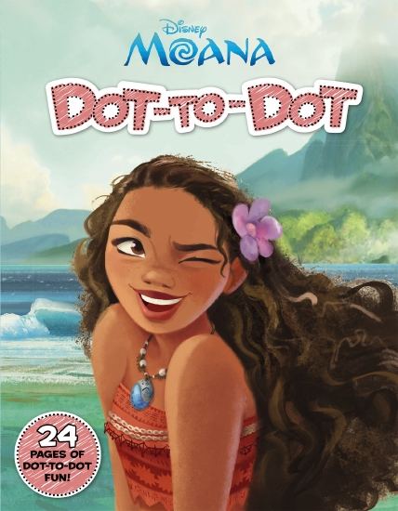

**Tools**

Drawing utensils (Pencil, pens, etc.)

Coloring utensils (Color pencils, colored pens, etc.)

**Steps**

1. Open the book to whatever page you wish to begin working on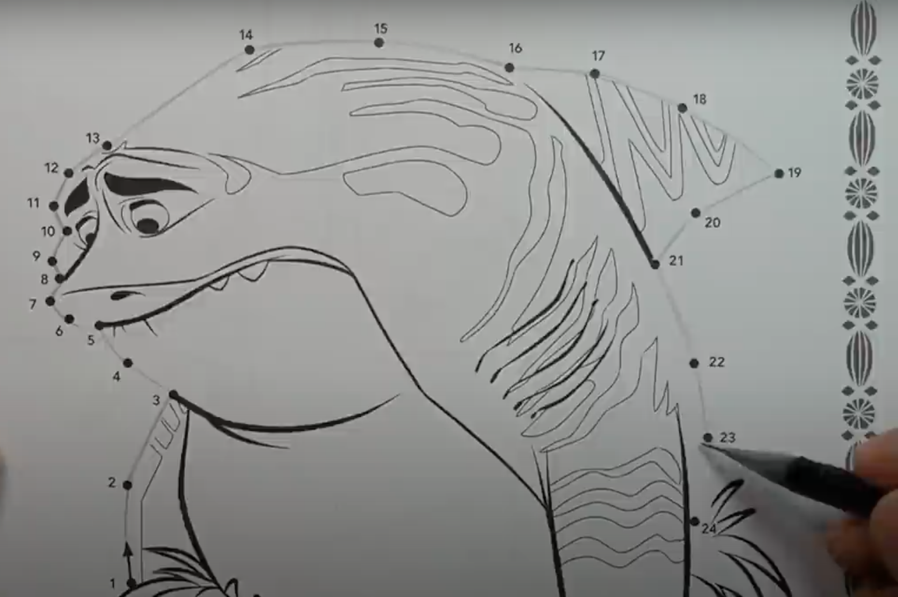
2. Using the drawing utensil, lightly draw lines connecting the numbers in sequential order.

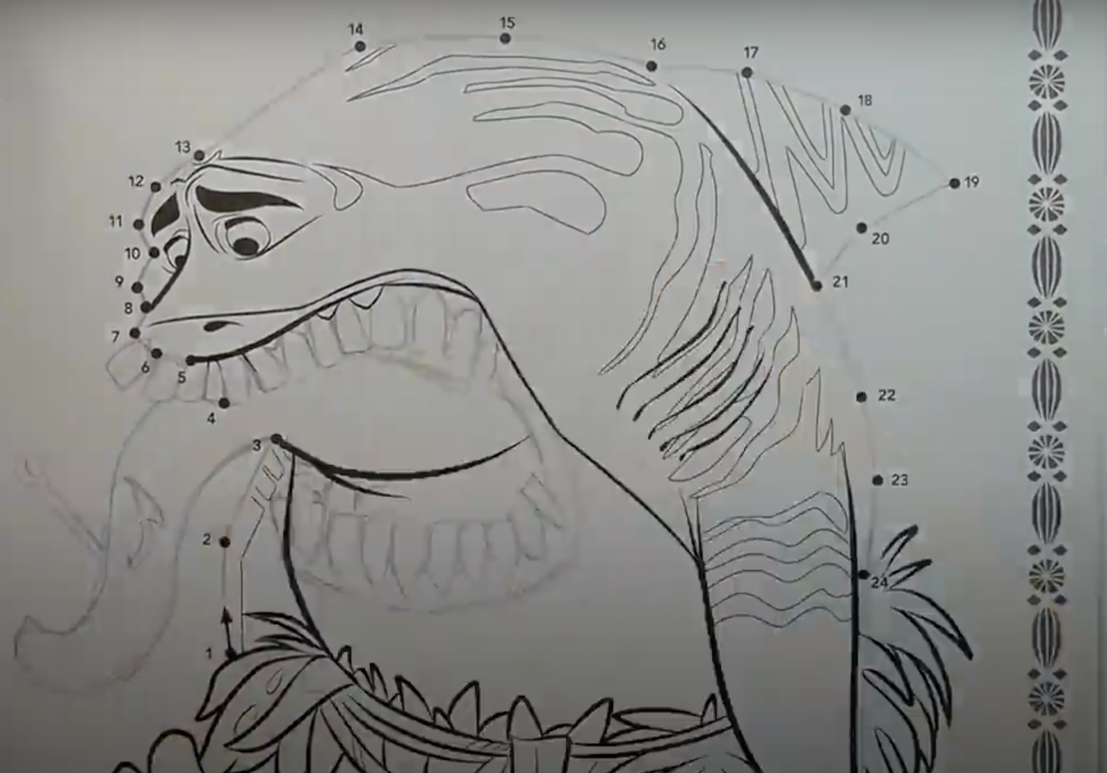

1. Optional: Change some lines as desired to modify the intended image.

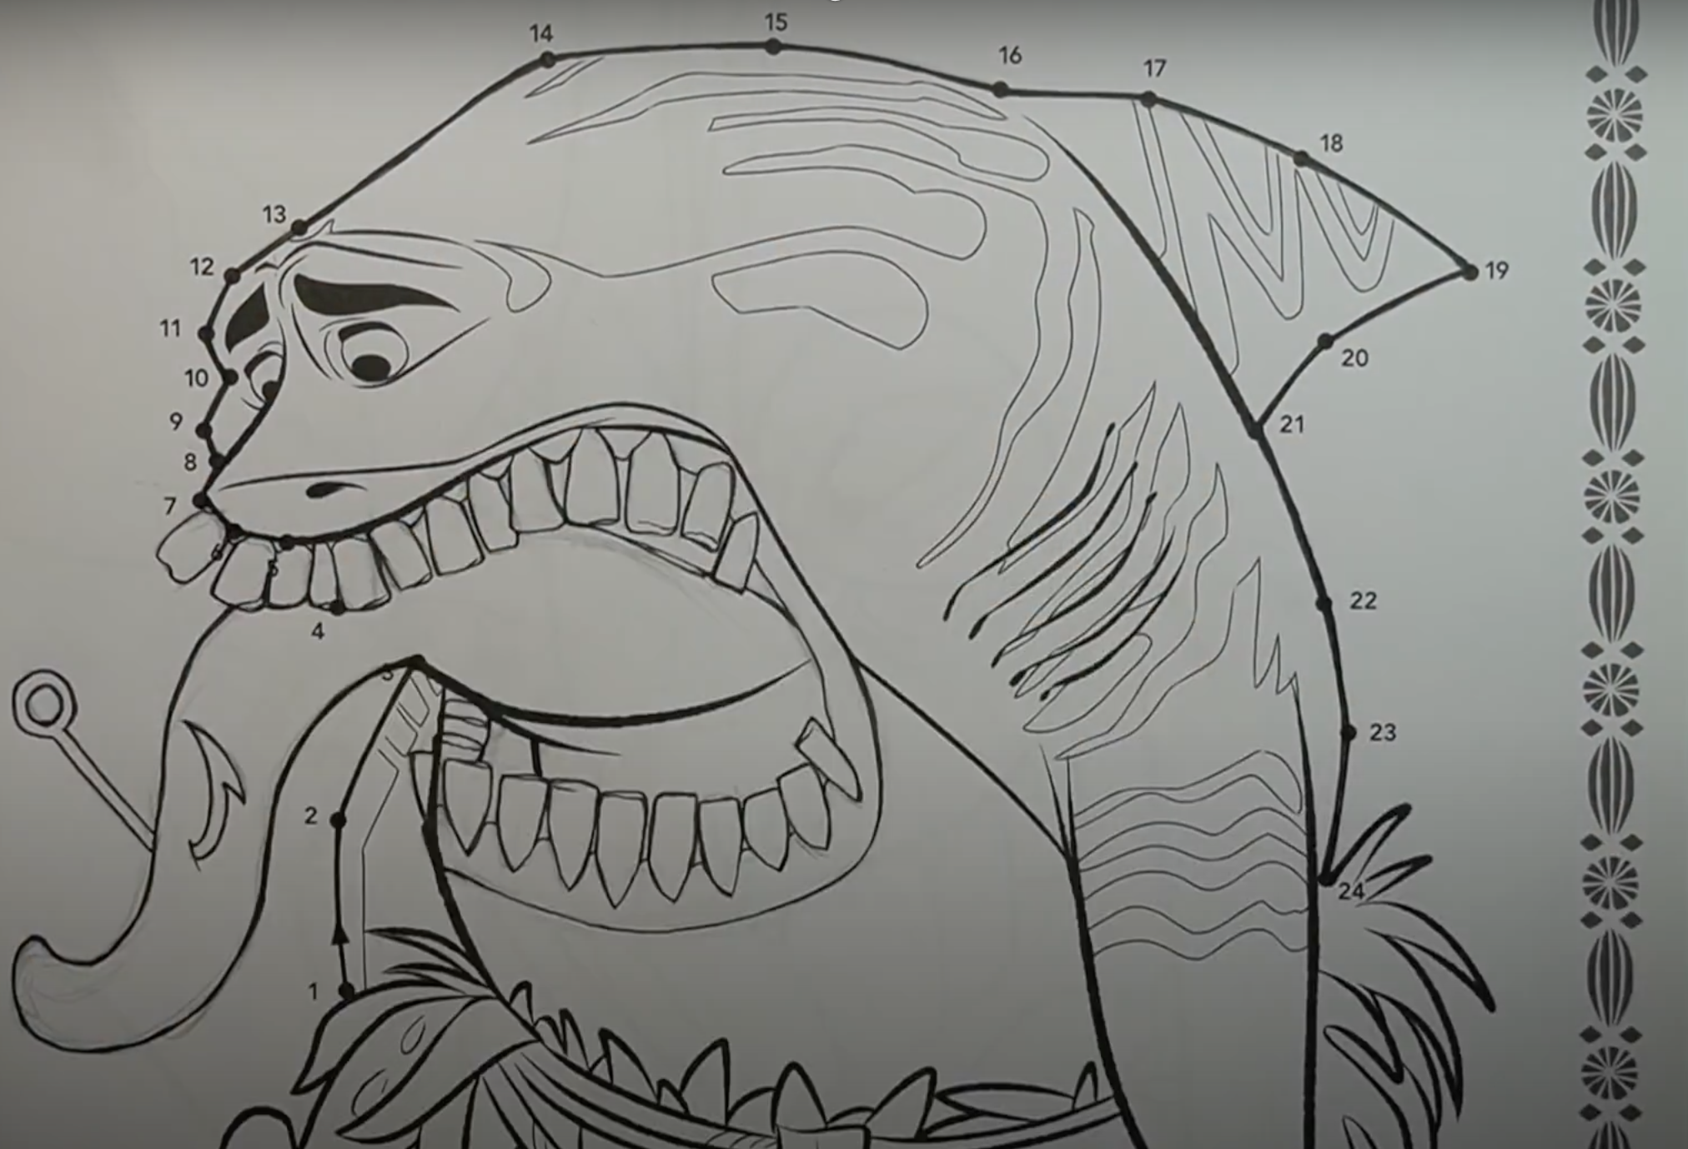

1. Darken the drawn lines when happy with the drawn image.

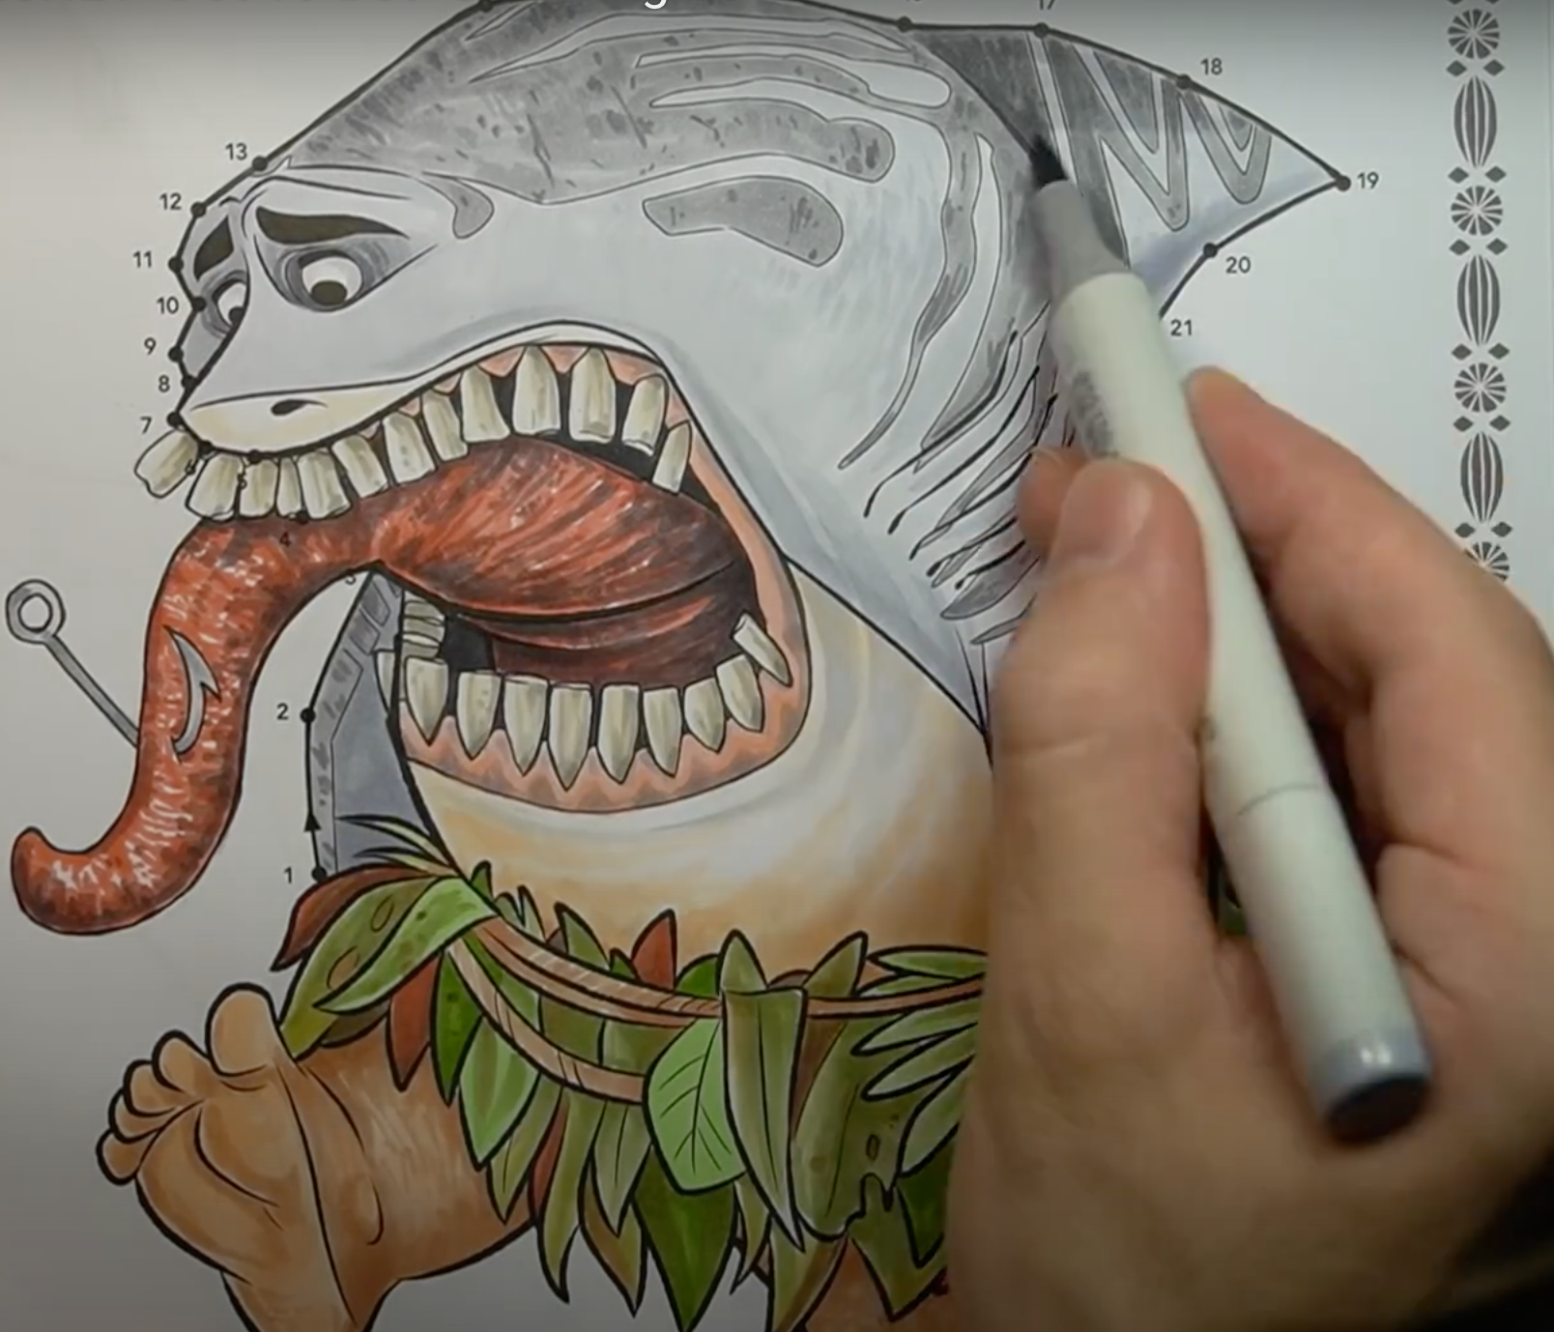

1. Using the coloring utensils, color in the drawn image as desired.

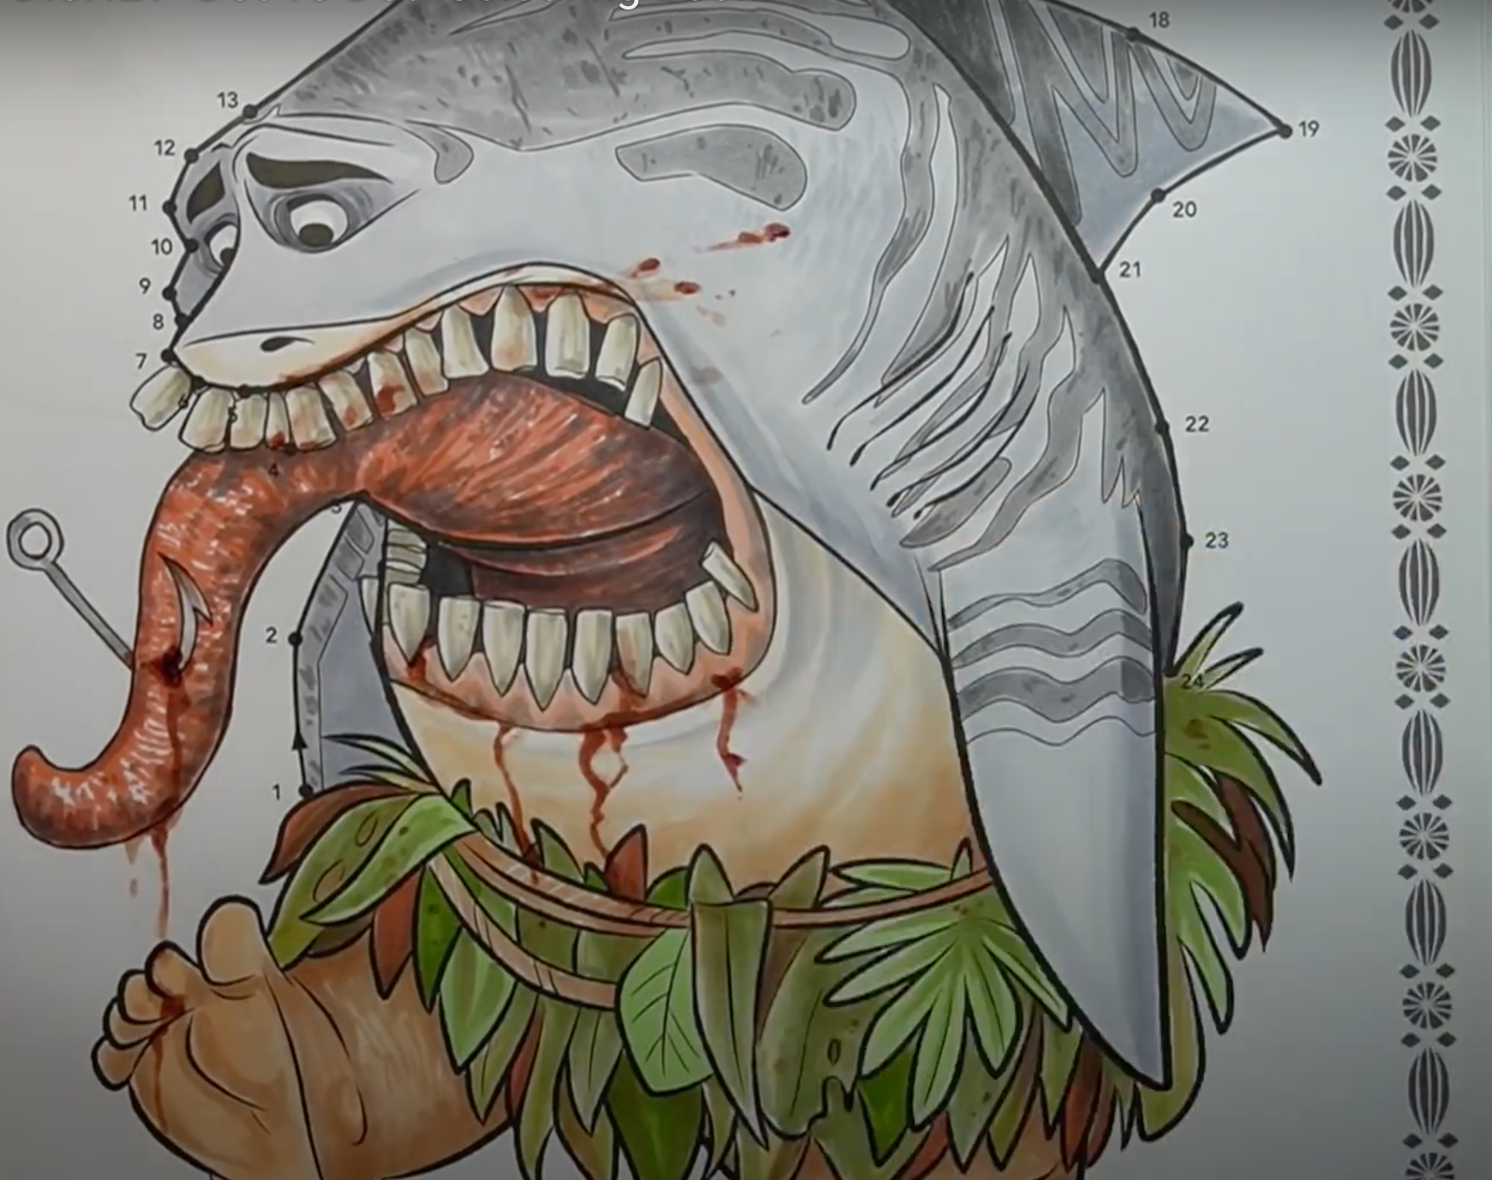

1. Optional: Add additional detailing to the image as desired.

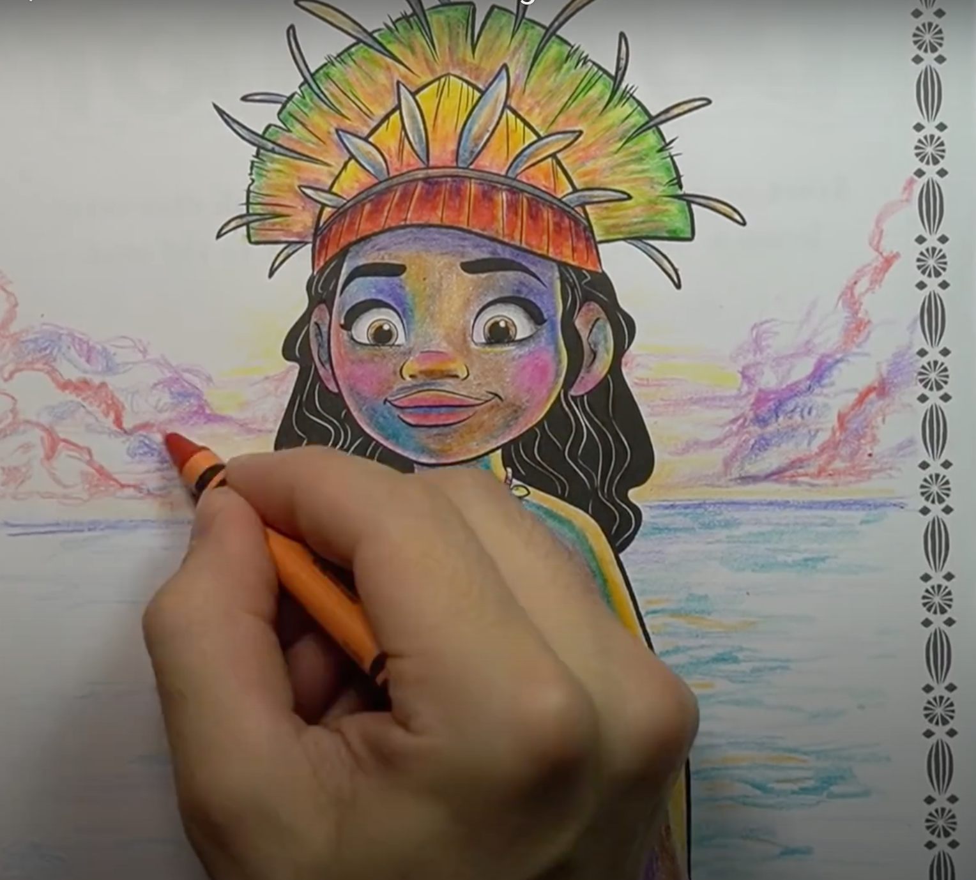

1. Optional: Add in background coloring.   
   Note: This may not be applicable for every image.
2. Repeat steps 1 through 7 for the other pages in the dot-to-dot coloring book.
3. Keep or dispose of the completed dot-to-dot coloring book as desired.
4. Optional: Applaud yourself or pat your back for a job well done.

**General Safety Information**  
 **WARNING**

Do not during any step consume the book, drawing utensils or coloring utensils.   
They may be a choking hazard and my not be non-toxic

**WARNING**

**Conclusion**

Congratulations! The dot-to-dot coloring book has now been completed! If you wish, you may keep the book to display/show others, dispose the book in whatever fashion you wish, or do anything else you may want to do with the book.

**Troubleshooting**

